Course Title: Computer Organization and Assembly Language

Task: Term Project

Section: BCS-3A, BCS-3B

**_____________________________________________________________________________**

**Phase IV**

**Deadline: Friday 25th November, 2022**

In the final phase of the project, you are required to implement a timer that records the time taken to complete the lap in Phase III. The timer should be displayed on the top right corner of the screen.

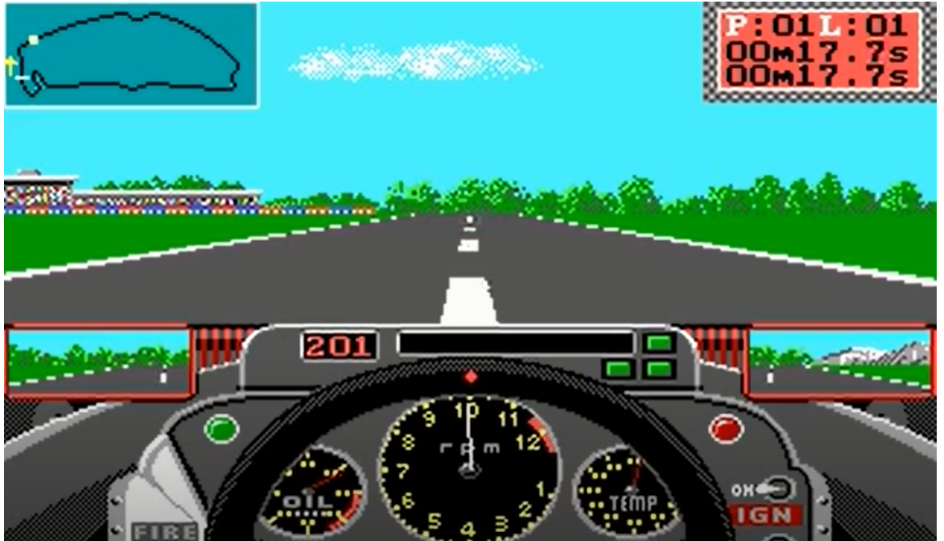

Furthermore, after the qualifying round is finished, you have to display the Qualifying Result Sheet as follows:

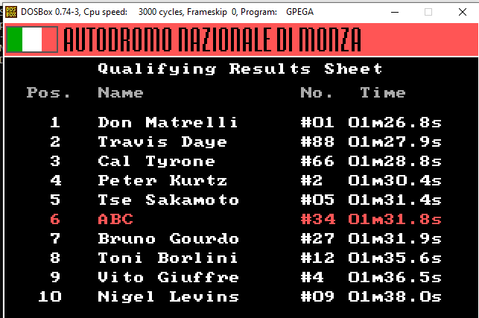

Please clearly list down any assumptions that you may make to implement this phase.

(Weightage: 3%)